|  |
| --- |
| The CCLVI logo - A pair of glasses . One eye which has been replaced with a globe and the other depicting a cross section of an eye pointed at the globe. The glasses themselves depict an image of an infinity symbol. |
| Volume 31 - Number 4 |

**Table of Contents**

Explore Membership in 2025 2

Affiliates’ Corner 4

How to Be Different and Confident Using Your Cane While Being Yourself 7

Smart Choices: Navigating Insurance for Ray-Ban Meta Smart Glasses 9

The Kitchen Corner 11

Book Club Information 16

Scout’s Sanctuary “Where Fun Meets Organization” 18

Make National Parks More Accessible by Joining “Descriptathon 11” 21

Explain it to Me Like I was 5, Why is Unsafe Walking Best for Blind Baby Development? 24

Calendar of Events 29

|  |  |
| --- | --- |
|  | **Point and Click**  **Your Way to CCLVI** |

# **Explore Membership in 2025**

by Zelda Gebhard, Membership Chair

There are always great things happening in CCLVI. Read below to find out how to renew your membership so you will not miss anything!

If you are a member of one of the following CCLVI Affiliates, you will be contacted by your affiliate representative to update your information and pay your 2025 dues: California Council of Citizens with Low Vision, Florida Council of Citizens with Low Vision, Kentucky Council of Citizens with Low Vision, Low Vision Now, and New York State Council of Citizens with Low Vision.

If you are an At-Large member (not belonging to one of the above affiliates) you will receive a large print paper renewal form in the mail. Please complete it and return it and your dues in the enclosed addressed envelope or go to <https://cclvi.info/join/member-form/> to complete the form and pay online before February 1st.

Of course, Life Members need not pay dues, but we would still like to connect with you. If you have had any changes in your contact information or format preferences for publications, please call Zelda at 701-709-0262 to update.

**Some Current Member Benefits:**

* Newsletter Vision Access, 4 issues a year in large print or email. Also, available on website at <www.cclvi.org> and soon to be podcasted
* Three weekly Zoom sessions to connect, share ideas and have fun!
* Monthly Let’s Talk Low Vision session for up-to-date information and education.
* Genensky–Foley Magnification Grant Awards
* Scheigert College Scholarships
* Bernice Kandarian Service Award, Friend of CCLVI Award
* Updated Website with Podcasts and revised Resource Pages
* Opportunities in Leadership as an Officer or on the Board of Directors or as a member of one of the 15 active committees

If you have any questions or need any assistance in completing your renewal, please contact Zelda at 701-709-0262 or <cclvimembership@gmail.com>.

2024 was a great year for CCLVI and we are looking forward to some exciting things in 2025. We encourage you to renew your membership and explore CCLVI in the new year.

# **Affiliates’ Corner**

**Low Vision Now is Still on the Move**

by Glenda Such, M. Ed.

Low Vision Now, formerly known as the Delaware Valley Council of Citizens with Low Vision, continues to be on the move. The newest major addition to Low Vision Now is our new phone number: (484) 566-3619.

The second addition is our new website which is continuously being updated. To make sure everyone can find us, people can reach our website by going to either LowVisionNow.com or .org. For those receiving this publication electronically, here are links to both:

<https://www.lowvisionnow.com> and

<https://www.lowvisionnow.org>.

When visiting our new website, people will find a great deal of information. For example, there is information about eye conditions that can cause low vision, resources helpful to those living with low vision, information to help people learn about the structure and functions of the parts of the eye, what happens when a doctor dilates a person’s eyes, and the instruments used during eye exams. We also have information and explanations about some eye procedures including corneal transplants, cataract surgery, repairing a detached retina, and Lasik surgery.

To help people understand what it is like to see with some of the conditions causing low vision, we have a page of simulations which may do the trick. Our Simulations of eye conditions page currently has videos showing such conditions as Macular Degeneration, Cataracts, Diabetic Retinopathy, Retinitis Pigmentosa, Glaucoma, and more. That page will be constantly updated as more simulation videos are found.

In addition, people can check out our website to learn the dates and joining information for each of our monthly Zoom meetings. If someone would like to listen to any of our previously recorded Zoom meetings, click the link “listen to past Zoom meetings.”

We invite everyone to visit our new website. It will be updated regularly with resources relating to our journeys with low vision.

**News from New York State Council of Citizens with Low Vision (NYSCCLV)**

by Kathy Casey, President

As I sit and watch the fall leaves change and feel the temperature in the 70s in the middle of October (just amazing), things are not too busy at the NYSCCLV. We are hoping to encourage some at-large members to become full members.

One of our on-going projects is with the District Transportation Authority. The Authority sought assistance with employee sensitivity training to assist blind/low vision patrons. NYSCCLV worked with the dispatchers who take reservations. It has been suggested that sensitivity training for drivers also be offered.

In other news, the NY Capital District Chapter of ACB is currently designing various emergency preparedness programs.

We look forward to providing additional news in the next issue of Vision Access.

# **How to Be Different and Confident Using Your Cane While Being Yourself**

**A Tips & Tricks Discussion from the 2024 ACB Convention**

Transcribed by Cynthia G. Hawkins

* Embrace both your advantages and limitations – without fear. Most importantly, do what makes you comfortable.
* Your cane is empowering Not necessarily limiting.
* Using your cane may telepath to others that you are low vision or totally blind. This may allow others to understand you more clearly. Do not be self-conscious.
* Realistically, if you do not use a cane, you may look like a victim. You will walk faster and without hesitation when using your cane.
* Wearing a pin or button that says “Hello, I’m low vision” may help with stranger recognition (in a positive way).
* When outside walking, as a safety measure, wear an orange/yellow “caution” vest that says “Caution -- Low Vision Walker.”
* Remember – we are partially sighted. We can always defend ourselves with our cane.
* Avoid your flight or fight mechanism. Fight or flight robs you of your considered decision-making. Take three deep breaths to disengage the fight or flight response.
* Realistically, low vision and blind people are more attentive to their surroundings than sighted people.
* Utilizing your non-verbal communication can be a deterrent to potential predators. Show others that you are aware of their presence.
* Remember, “Aira” and “Be My Eyes” are available to assist you – even in times of trouble.
* Embrace yourself while building your independence.

These tips & tricks were provided by audience members during the “Looking How I’m Feeling” session at the July 2024 ACB Annual Conference and Convention. This program has been podcasted.

# **Smart Choices: Navigating Insurance for Ray-Ban Meta Smart Glasses**

by Cheryl McNeil Fisher

Since publishing my article about the Ray-Ban Meta Smart Glasses, I am excited to share that I purchased a pair of Ray-Ban Meta Smart Glasses with prescription lenses at Lens Crafters, utilizing my insurance benefits. The insurance covered $250 of the $299 price under frames, which was a pleasant surprise. Additionally, the eye exam was fully covered, and a portion of the lenses were also included, making the overall experience quite economical. However, when I inquired about adding blue light protection, I learned it would cost an additional $25. While I found this fee reasonable, the office manager took it upon herself to add anti-glare, which was another $49.

Despite this minor hiccup, I am genuinely happy with my decision to invest in these smart glasses. The minimal prescription lenses give me a bit more clarity than I have without, adding another positive to the experience.

I remind everyone to ensure they have a clear understanding of what is covered by their insurance before making a purchase, as it can save you from unexpected expenses. Furthermore, if you have a Medicare plan that allocates funds for over-the-counter needs, you can use that towards your Ray-Ban Meta Smart Glasses, an excellent option for those seeking to maximize their benefits.

The glasses have opened a new world of possibilities for me. I can now navigate my environment with greater ease, and the ability to read labels and menus independently has been liberating. I also appreciate the convenience of making video calls and sharing experiences in real-time, which has strengthened my connections with friends and family.

As I continue to explore the features of the Meta Smart Glasses, I am eager to see how they will evolve with future updates. Meta's commitment to enhancing accessibility for individuals with visual impairments is commendable, and I look forward to the potential new features that may be introduced.

If you have questions about the Ray-Ban Meta Smart Glasses, you can send an email to [cmcneilfisher@gmail.com](cmcneilfisher@gmail.com%20)

# **The Kitchen Corner**

**Cutting Safety: The Corral Method**

by Debra Erickson

There is no one best method to cut foods. Foods vary in size, density, and shape. This month is focused on the “Corral” method which is excellent for cutting food into very small pieces with no need for a specific shape, but just very small pieces. Many times, the recipe will call for the cook to “mince” the garlic. Other recipes will direct the cook to cut the fresh herbs into small pieces. Fresh parsley, cilantro and dill are commonly cut into very small pieces. If small pieces are the outcome you desire, this is an excellent method to get that result safely and efficiently.

Note: A chef knife is the best tool for this method. A blade length of six to eight inches (not including the handle) will work for most cooks. <https://theblindkitchen.com/product/knife-sharpener-with-cut-glove/>

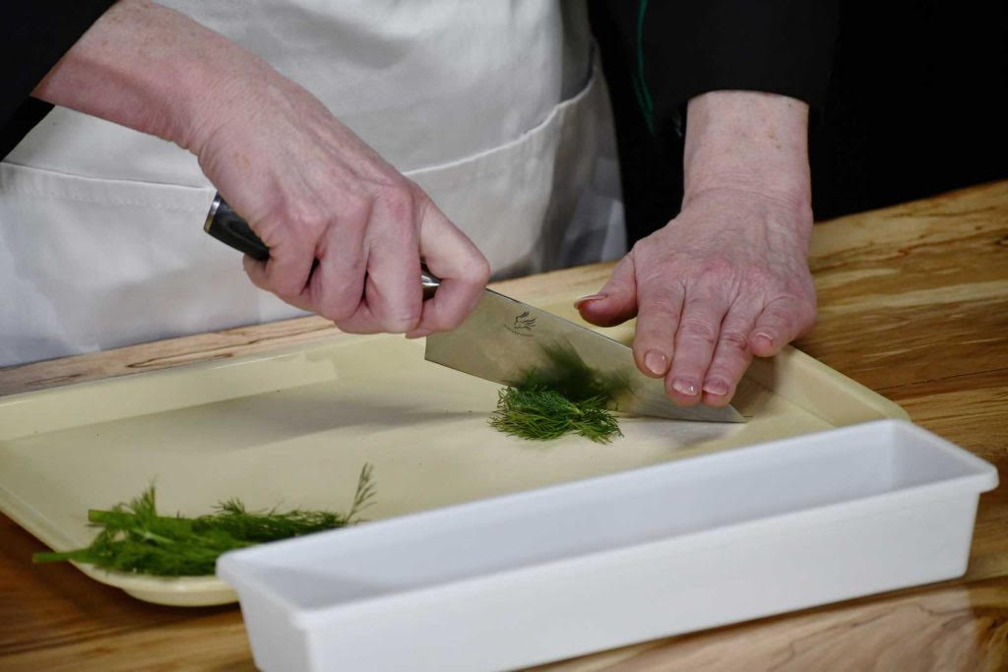

Photo Above: The image shows a close-up of hands chopping dill on a yellow cutting tray. The tray has upturned sides to help prevent cut pieces from spilling onto the counter. One hand is holding a knife, while the other hand steadies the herbs on the tray. The person is wearing a white apron and the tray is on a wooden countertop. A white rectangular container is placed nearby. The focus is on the technique of chopping herbs.

<https://theblindkitchen.com/product/work-trays/>

Step 1: Place the clean and trimmed food you want to cut into a pile on your cutting surface.

Note: The Blink Kitchen (TBK) recommends that you wear a “Cut Glove” on the hand that is holding the food that will be cut. It is quite flexible and is made of cut resistant threads that cannot be cut by your knife.

<https://theblindkitchen.com/product/cut-glove/>

Step 2: Hold the knife firmly by the handle in your dominant hand taking care to pinch the blade of the knife blade closest to the handle between your index finger and thumb, while the other three fingers are wrapped safely around the handle ensuring safe spin-free control of the knife.

Step 3: Locate the center of the section of food to be cut and place the tip of your knife blade to the side of that portion of food. You will not lift the tip of your knife off the board when performing this cutting method. Instead, the tip knife will serve as your anchor point and will not be lifted for this method. Place the index finger of your non dominant hand on the back of the blade so it is pressing the tip of the knife firmly to the cutting surface. Now you will use that anchor point as a focus for the next steps.

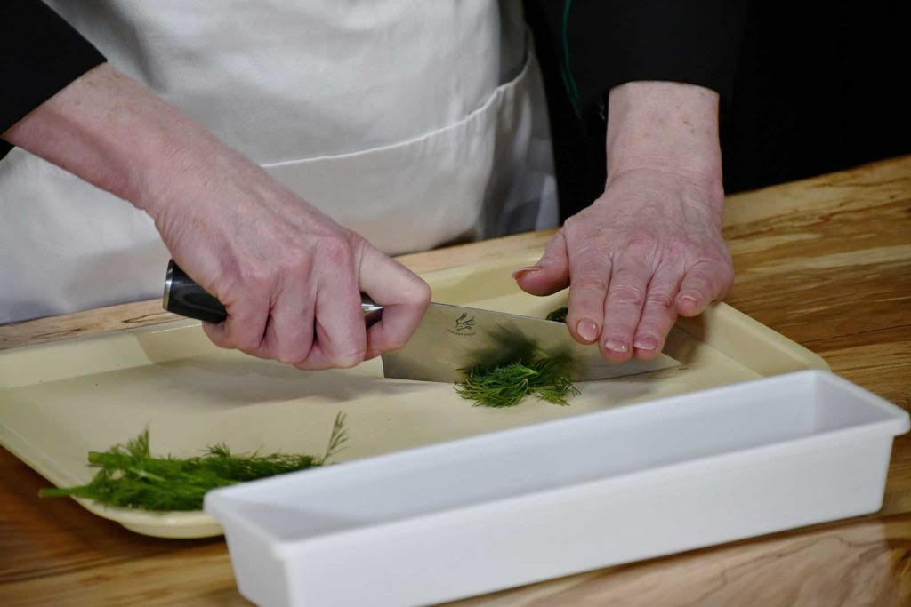

Photo Above: Chef Debra anchors the blade to the cutting surface by putting the index finger of her non-dominant hand on the back of the blade so it is pressing the tip of the knife firmly to the cutting surface.

Step 4: Lower the handle of the knife through the food until it reaches the cutting surface making one cut through the food. Do not release the tension in your non dominant index finger that is holding the point of the knife to the cutting surface.

Step 5: Lift the knife handle, while holding the tip of the blade in the same spot and rotate the knife a very short distance, maintaining your anchor, and once again lower the handle of the knife causing the blade to cut through a second section of the food. Your blade tip should still be held to the same anchor point.

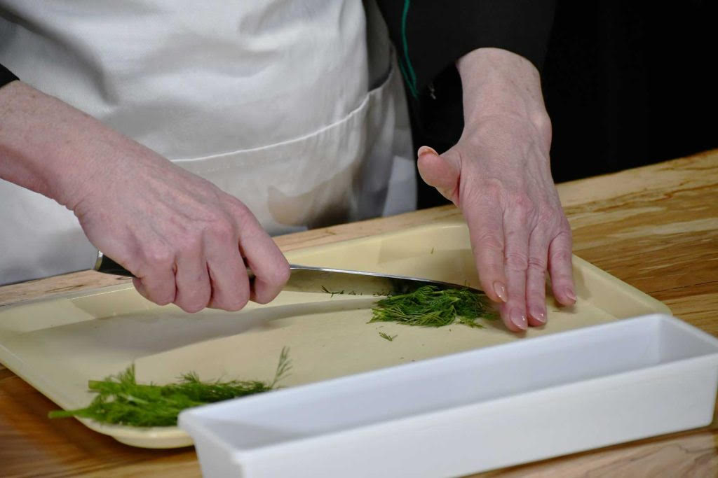

Photo Above: Chef Debra demonstrates how to rotate the knife a very short distance, still anchoring the blade to the cutting surface, and again lower the handle of the knife causing the blade to cut through a second section of the food.

Step 6: Repeat until you have cut through all the food in that section one time. Check the food to see if it is the size you desire.

Step 7: If you would like to cut the food into smaller pieces you need to “corral” or gather the partially cut food into a pile on your cutting surface. Again, anchor the tip of the knife blade to the cutting surface in roughly the center point to one side of the pile and again do the rotating cuts from one side of the pile to the other. Repeat this until the pieces are as small as you desire.

# **Book Club Information**

**November 2024: The Briar Club**

* Author: Kate Quinn
* Book Number: DB122866
* Reading Time: 15 hours, 4 minutes
* Narrated by: Saskia Maarleveld

Book Description:

"The New York Times bestselling author of The Diamond Eye and The Rose Code returns with a haunting and powerful story of female friendships and secrets in a Washington, DC, boardinghouse during the McCarthy era"

**December 2024: A Christmas Carol**

* Author: Charles Dickens
* Book Number: DB 43546
* Reading Time: 3 hours 28 minutes
* Narrator: Clark Niederjohn.

Book Description:

Classic nineteenth-century Christmas story set in England describes the conversion of grasping old miser Ebenezer Scrooge when he is visited by ghosts of Christmas past, present, and future.

**January 2025: Not Fade Away: A Memoir of Senses Lost and Found**

* Book Number: DB 80043
* by Alexander, Rebecca,
* Reading Time: 7 hours 59 minutes
* Narrated by: Kate Kiley

Book description:

Autobiography of a woman born with Usher's syndrome, a genetic condition that causes the gradual loss of hearing and vision. Chronicles the progression of her condition, describes dealing with her diagnosis as a young adult, and recounts a devastating accident that left every bone in her body broken. 2014.

# **Scout’s Sanctuary “Where Fun Meets Organization”**

by Cheryl McNeil Fisher

Left: The image shows a

close-up of a fluffy,

light reddish brown

(called Fox red) dog

with a wavy coat.

The puppy has a sweet

expression with dark eyes

and a black nose.

Greetings my new friends!

I’m Scout, a charming three-month-old Labradoodle, as delightful as an Eagle Scout. My dad is a blonde standard poodle, and my mom is a fox-red Labrador retriever. With my wavy fur and stunning reddish coat, I have even been mistaken for an Irish Setter by the vet!

I want to share about my new crate home, which Cheryl has transformed into a cozy haven. She replaced her nightstand with my special space though I prefer to call it my sanctuary. On top, she placed a black exercise mat, creating a snug roof while providing a perch for her gadgets, including curious device she calls “Lady A.”

Cheryl had a garbage bag hanging on the outside of my sanctuary with one of those shower hooks she likes. I saw that and, oh boy, I turned it into a playful toy, tossing it around my crate like a wild whirlwind until she reclaimed it and gave me a bone to chew instead.

Speaking of organization, Cheryl has four rows of hanging cup holders (quite the quirky setup) on the side of my crate, next to her bed, for easy reach! She weaves wire in and out of the crate and clips on the cups. It’s a sight to behold! She has sleek black cups, some adorned with wild black-and-white contact paper, arranged in an alternating pattern that looks absolutely fabulous. On the first row, she added one on the front of my crate for her coffee mug.

She cleverly organized cups for her lotions and potions in a lower row. Near the top, she has designated a cup for her Apple Watch when charging, one for her headset, one for her Victor Reader, her iPhone, and a couple of other things I’m not sure about. On the back, she hung a big square power source that I cannot reach, then taped her cords to each cup. She told me that it is so much easier than figuring out the wires each time she puts something in the cup to charge.

Oh yeah, she has her Ray-Ban Meta Glasses in one too. When she travels, she uses double-sided tape that is gentle on walls and nightstands, securing three cups to organize and prevent knocking things over and mishaps. Sometimes the drawers are deep enough for them, making it an organizing haven with cups. If there is room for four, the fourth one closest to the bed is for her coffee mug. She told me that is important.

For more information about the 8pcs Hanging Cup Holder Utility Rolling Cart Organizer Accessories, Hanging Makeup Pencil Holder, Space Saving Kitchen Storage please visit <https://bit.ly/4eZsWlM>

If you have questions about them or about me, Scout, feel free to reach out to Cheryl at <cmcneilfisher@gmail.com>.

It is a pleasure to share my world with you!

Your friend,  
Scout

# **Make National Parks More Accessible by Joining “Descriptathon 11”**

by Brett Oppegaard

If you want to improve access to visual media in national parks including photographs, illustrations, and maps, our hackathon-like Descriptathon might just be for you. This fun and friendly workshop gives you an opportunity to do something significant about a widespread access issue through a collaborative online training focused on producing public Audio Description.

The Uni Description Project is a University of Hawaii-based research initiative. Now through the end of the year, the Project is offering a limited number of grant-funded positions at no-cost, for participants who are Deafblind, blind, or who have low vision.

In short, this workshop brings together national park staff, external volunteers, and members of the target audience (people who cannot see or who cannot see well) to co-create Audio Descriptions of the orientation brochures offered at national park visitor centers across the country. Those descriptions then are shared through a free mobile app called “Uni Description” and via NPS websites and apps.

This next Descriptathon (D11), will include a range of participating sites from the Juan Bautista de Anza National Historic Trail, which starts on the West Coast in California, to the Grand Teton National Park in Wyoming, to the White House and President’s Park in Washington, D.C.

The Descriptathon is a three-day and online-only workshop, from Feb. 25-27, 2025. All the synchronous activities happen on Zoom (noon to 5 p.m. EST Feb. 25, 2 to 4 p.m. EST Feb. 26, and noon to 5 p.m. EST Feb. 27). This intensive training will revolve around assigned activities and small-group collaborations among team members dispersed throughout the United States and the world. While grants cover the costs of your participation, the time commitment for the event is significant, including the three full days of activities, plus about 10 hours of prep time during late-January and February.

About 200 U.S. national parks have participated in our 10 Descriptathons over the past decade, including diverse and iconic Americans places - namely, Yellowstone, Hawaii Volcanoes, the Golden Gate National Recreation Area, the Lincoln Memorial, and the Statue of Liberty.

The Descriptathon uses a “gamified, hackathon-like” format to prompt motivation and engagement in its participants and to cover major genres of Audio Description, including how to describe people, objects, and maps. Working in teams, each group creates descriptions as a part of the genre training while also working independently on their site’s brochure.

For example, the roughly 10 members of the 2024 Everglades National Park team will practice common describing challenges, like how to describe the complex flora and fauna of their specific site, as a group, but individuals on the team simultaneously will be practicing their own descriptions, in the genres, and learning about Audio Description best practices as a form of continuing education.

All participants who finish the training will receive a Certificate of Completion. To get involved, please contact the event organizer, Dr. Oppegaard, either via email (brett.oppegaard@hawaii.edu) or via phone at:

(360) 521-8150.

# **Explain it to Me Like I was 5, Why is Unsafe Walking Best for Blind Baby Development?**

by Dr. Grace Ambrose-Zaken, COMS Inventor of the Pediatric Belt Cane

Recently blinded adults have always understood the value of safe mobility. From the earliest recorded history, newly blinded adults have restored their safety using a stick, staff, or animal guide. The same cannot be said of those who were born blind.

Parents have always had great difficulty teaching their infants born with mobility visual impairment or blindness (MVI/B) to let go of them and walk freely. Parents expend a lot of energy to get their preschoolers with MVI/B to take a few unaided steps. Until now, parents have had no way to help their children with MVI/B to safely walk independently.

In their 1797 Encyclopedia Britannica article, Drs. Blacklock and Moyes recommended to parents that it would be better that the child with MVI/B “should lose a little blood, or even break a bone than be perpetually confined in the same place, debilitated in his frame and depressed in his mind.”

This sounds very close to modern-day advice given to parents in response to their request for help teaching their infants with MVI/B to safely walk independently. The two blind men that wrote this encyclopedia article knew, like everybody else, that young children with congenital or early onset mobility visual impairment or blindness (MVI/B) do not walk independently when evaluated using standard age-based descriptive walking milestones.

Infants with MVI/B are uniquely challenged when it comes to independent walking due to the essential role vision plays in early balance and safety.

Yet, parents have been told since 1797 that the problem is the solution – the solution is the problem.

The problem– “my blind child doesn’t walk very much, very well or very far.”

Solution: “Try harder to get your child to walk” but that’s the problem, my child won’t walk)

The Problem: My child gets hurt when he walks independently – it’s unsafe.

The solution: “Yes, correct -that’s right” (but that’s the problem- they’re unsafe)

We invented pianos, typewriters, rocket ships to the moon and long, white canes for physically and intellectually capable adults – but in 200 plus years we can think of no way to keep blind babies safe? So instead, we simply advise parents to stop trying to keep your blind babies safe and just make them walk anyway.

However, so far, that has not worked out for the blind babies at all. Instead, the primary method of addressing the walking delays in children with MVI/B was to provide them with a physical support system, such as a rear facing walker that the child drags around behind them so that they have something to steady themselves with.

Ambrose-Zaken (2023) evaluated 562 children with MVI/B between 8 and 180 months of age (n=543, M=41.49 months; Σ=25.49). Sixty percent of those children received physical therapy and used various physical support devices, although there was nothing wrong with their legs or feet.

Over 75% of the sample reported their children with MVI/B were unable to walk solo although participating in early education therapies. Parents said they had no way to give their children a safe and effective way to participate independently in their recommended daily physical activity. They reported that the challenges of helping their children use hand-held mobility tools correctly and consistently prevented them from participating safely in most activities.

Children with MVI/B-related balance challenges are not structural, they are sensory based. Therefore, the answer lies in providing them with tactile and auditory information about the nature of the walking surface, detecting the presence of objects and drop-offs. Ambrose-Zaken (2022) provided 35 children with MVI/B aged 14–69 months (x =33.2 months, Σ=12.36) with Pediatric Belt Canes and evaluated their walking milestones before and after introduction of the toddler-designed white cane.

The Pediatric Belt Cane consists of a belt that connects to a rectangular cane frame with magnets. The white cane frame’s tips maintain contact with the floor. The Belt Cane is a lightweight two-step, safety buffer between the child and danger. It does not offer physical balance support, instead it is designed to provide additional sensory feedback (e.g., auditory, and haptic) and prevent most forward collisions. Children with MVI/B wearing the Belt Cane walked better, farther and with greater joy.

Safe mobility makes a difference in how much blind babies walk. Parents are demanding more choice in safe mobility tools. Let’s start with better safe mobility options for babies, people in wheelchairs, people who have no hands, children who are MVI/B but are not safe using the long cane. Next, let’s make safe mobility tools for all games and sports on all terrains and in all climates. Just because you cannot see or see well– shouldn’t mean you have to be unsafe when you just want to have fun.

# **Calendar of Events**

Everyone is welcome to attend these events by accessing the Zoom mobile app, visiting the Zoom website at <https://zoom.us> or calling (312) 626-6799, and entering the appropriate meeting ID and passcode.

Subscribe to our CCLVI-Info email list to receive weekly meeting reminders and Zoom details by emailing <CCLVIWebmaster@gmail.com>. In addition, all CCLVI events, except our business meetings, are listed on the ACB Community Call schedule. Those without email can access that information by calling 1-800-424-8666 and following the prompts.

**CCLVI Low Vision Discussion**

Themed chats—First Monday at 8:00 PM ET

Speaker or Themed chat - Fifth Monday at 8:00 PM ET

Meeting ID: 896 8650 7068

Passcode: 225846

**CCLVI Game Night**

Second and fourth Mondays at 8:00 PM ET

Meeting ID: 896 8650 7068

Passcode: 225846

**CCLVI Low Vision Peer Support Group**

Third Monday at 8:00 PM ET

Meeting ID: 896 8650 7068

Passcode: 225846

**CCLVI Board of Directors Meeting**

Second Tuesday at 8:30 PM ET

Webinar Meeting ID: 829 0433 3824

Passcode: 784688

**Let’s Talk Low Vision**

Join our guests for this monthly informative program

First Thursday at 8:00 PM ET

Meeting ID: 874 7608 2312

Passcode: 225845

**CCLVI Table Talk Thursday**

Weekly calls on a variety of topics related to low vision

Thursdays at 8:00 PM ET (except for Book Chat week)

Meeting ID: 828 1584 6310

Passcode: 225848

**CCLVI Monthly Book Chat**

Third Thursday at 8:00 PM ET and the following Friday at 11:00 AM ET

Meeting ID: 898 0359 8659

Passcode: 225843

**CCLVI Affiliate Zoom Calls**

**California Council of Citizens with Low Vision (CCCLV) – A Sunday Chat**

Spend part of your Sunday with members of CCCLV and enjoy “A Sunday Chat”. This is a call for those of us who are blind or with low vision and any family and friends, be they near or far. Topics will range from all things low vision to life in general as a person who is blind or low vision.

First and Third Sunday at 7:00 PM ET

Webinar Meeting ID: 859 2669 0965

Passcode: 282367

**Low Vision Now(formerly Delaware Valley Council of Citzens with Low Vision)**

The monthly Zoom meeting Low Vision Now is open to all who have an interest in the issues of low vision.

First Saturday at 12:45 PM ET

(2nd Saturdays in July and September)

Webinar Meeting ID: 440 465 3663

Passcode: 2121

Saturday, December 7, 2024

Group Discussion facilitated by Sarita Kimble, M.S.

Topic: TBD

Saturday, January 4, 2025

Speaker: Barbara Milleville, Ombudsperson for Riders with Disabilities, Washington Metropolitan Area Transit Authority, Washington, DC

Topic: Let's Go! Trending Ways to Jumpstart Your Independent Living without Car Keys

Saturday, February 1, 2025

Speaker: Doctor Sarah Noble, Psychiatrist, Medical Director, Outpatient Behavior Services, Einstein/Jefferson Health Services.

Topic: Trauma

**Kentucky Council of Citizens with Low Vision (KCCLV) - Low Vision Support Calls**

First Wednesday at 8:00 PM ET: Business Meeting

Third Wednesday at 8:00 PM ET: Informative meetings for low vision individuals across the US

Meeting ID: 862 9889 6972

Passcode: 975864

*Topics and speakers are subject to change. Please reference the weekly CCLVI emails and ACB Community Call schedule.

|  |  |
| --- | --- |
| **OFFICERS**  **President - Patti Cox 2024-2026**    **1st Vice President - Zelda Gebhard 2023-2025**    **2nd Vice President – Terry Pacheco**  **2024-2026**    **Secretary - Melanie Sinohui 2024-2026**    **Treasurer - Debbie Persons 2023-2025**    **Immediate Past President**  **Leslie Spoone**  **Publications Chair**  **Melanie Sinohui** | **DIRECTORS**  **Cynthia Hawkins 2023-2025**  **Kathy Farina**  **2024-2026**  **Joyce Feinberg  2023-2025**  **Paul Lewis**  **2024-2026**  **Dianna Leonard**  **2024-2025**    **Donna Williams**  **2024-2026**  **Webmaster**  **Joyce Feinberg** |

VISION ACCESS is published February 15, May 15, August 15, and November 15 in large print and email. We welcome submissions from people with low vision, professionals such as ophthalmologists, optometrists, low vision specialists, and anyone with something substantive to contribute to the ongoing discussion of low vision and all of its ramifications. Submission deadlines are January 15, April 15, July 15, and October 15. Send contributions to [CCLVIVisionAccess@gmail.com](mailto:CCLVIVisionAccess@gmail.com)

DISCLAIMER: The opinions expressed in the content of this newsletter do not necessarily reflect the opinions of the Council of Citizens with Low Vision as an organization.