|  |  |  |
| --- | --- | --- |
| The CCLVI logo - A pair of glasses . One eye which has been replaced with a globe and the other depicting a cross section of an eye pointed at the globe. The glasses themselves depict an image of an infinity symbol. | **VISION ACCESS**  Council of Citizens with Low Vision International | |
| Volume 31 - Number 3 | https://cclvi.org | August 2024 |

**Table of Contents**

President’s Message 2

CCLVI Annual Business Meeting Recap 3

CCLVI at the 2024 ACB Conference and Convention 6

2024 CCLVI Awards 8

Meet the 2024 Fred Scheigert Scholarship Winners 10

2024 Genensky-Foley Magnification Award Winners 13

CCLVI Membership Interest and Satisfaction Survey Report 14

Affiliates’ Corner 15

Have You Heard the Buzz? 17

The Makapo Aquatics Project Levels the Paddling Field for the Visually Impaired (Part 2) 20

Calendar of Events 27

|  |  |
| --- | --- |
|  | **Point and Click**  **Your Way to CCLVI** |

# **President’s Message**

by Patti Cox

I would like to thank Tom Frank and Renee Zelickson for their work on the CCLVI board. Your opinions and the expertise you brought to the board will surely be missed.

Now, I would like to welcome our newest board members - Kathy Farina from New York and Paul Lewis from Florida. Kathy Farina has been a board member in the past and now is a Director. She is also our Fundraising Committee Chair and has done a fabulous job. Paul Lewis has been a member of the Fundraising Committee and played an instrumental part in helping Florida Council of Citizens with Low Vision become a part of CCLVI again. We are excited to have Florida back as a chapter of CCLVI.

This year we are going to be doing a lot of work. We are looking at re-branding CCLVI and possibly changing our name going into convention next year. We need to write some resolutions to make the ACB convention more accessible to those of us with low vision. We will also be looking at our Constitution and Bylaws and making the changes that are needed for us to run more efficiently and effectively.

We know that our website needs changes and they are being addressed. Our webmaster is continuing to broaden her knowledge on how to make our website better. This is not something that will happen overnight, so please be patient as we are making progress. If there are changes that you feel need to be made, please let us know.

I am currently putting together our committees. If you are interested in serving, please let me know. We need our members to be a part of our committees, to be a part of the changes, and to share your talents with us.

This is your organization, so share a little bit of you with us and we will make it great.

2024-2025 will be a great year!

# **CCLVI Annual Business Meeting Recap**

CCLVI’s Annual Business Meeting was held virtually on June 22, 2024. A review of the year was presented by each committee and elections were held with the following results:

* President (2-year term): Patti Cox
* 2nd Vice President (2-year term): Terry Pacheco
* Secretary (2-year term): Melanie Sinohui
* Director (2-year term): Kathy Farina
* Director (2-year term): Paul Lewis
* Director (2-year term): Donna Williams

Please help us welcome Kathy and Paul as the newest members of the CCLVI Board of Directors

**Kathy Farina**

Kathy Farina is chair of the Fundraising Committee. She is a member of the Fred Scheigert Scholarship and e-Communications Committees. She is married and lives with her husband in Albany, New York. Kathy is secretary of the Capital District chapter of the American Council of the Blind. She enjoys knitting, crocheting, amateur radio, and going for walks with her guide dog, a black lab golden retriever cross, named Kenya.

**Paul Lewis**

I attended my first state convention in 2010 Daytona Beach, Florida. I became very excited and looked forward to attending a special interest affiliate, the Florida Council of Citizens with Low Vision (FCCLV). It was also at that meeting that I was elected to my first office as secretary of the chapter. From there, I became 2nd VP, 1st VP, and then President. During this time, I was also an active participant in my local chapter, serving on a number of committees. I wanted to become more involved at the state level and began attending the midyear board meetings, even when I did not attend as a chapter Board Rep. I have also served and continue to serve on a number of state committees, which currently include Constitution & Bylaws, Project Insight, and Government Access. During the years when the DC Leadership Conference was virtual, I was a member on FCB’s teams that spoke with our elected representatives. I have also been acknowledged for my service by my local and state affiliates as a recipient of local chapter, special interest affiliate, and state awards.

Currently, I am serving as the chair of the Constitution and Bylaws and Resolutions Committee and am a member of the Fundraising and Membership Committees of CCLVI. I am also a member of several other ACB special interest affiliate including Alliance on Aging and Vision Loss, Library Users of America, ACB Diabetics in Action and ACB Lions.

I have a background in retail sales and management. I have also worked in customer service and quality control in the printing industry.

I have learned the importance of listening to others and developing the ability to be able to talk to nearly anyone from any type of background, regardless of their position and their location or social standing.

# **CCLVI at the 2024 ACB Conference and Convention**

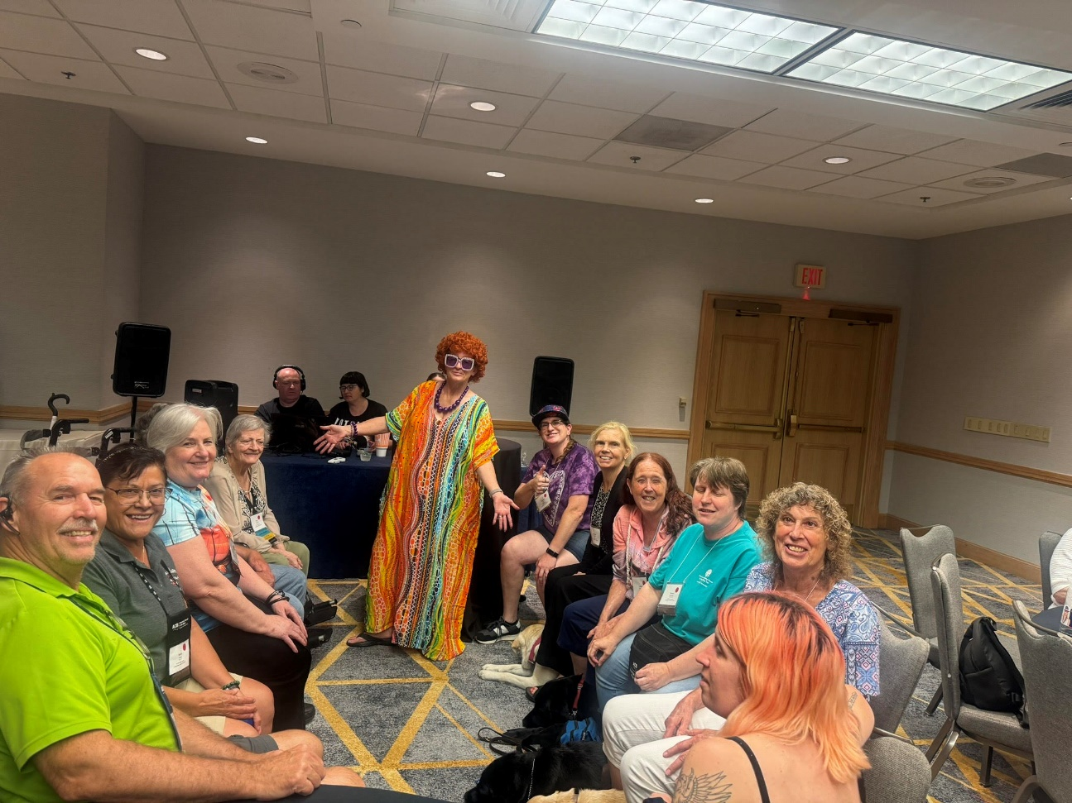Mrs. Roper (Patti Cox) hosted CCLVI’s Family Feud this year. Two teams competed at a time to guess which responses were most answered to a survey question. The photo above shows two teams of five including Terry Pacheco, Zelda Gebhard, Debbie Deatherage and others along with Mrs. Roper. (Photo by Samantha Hubbard)

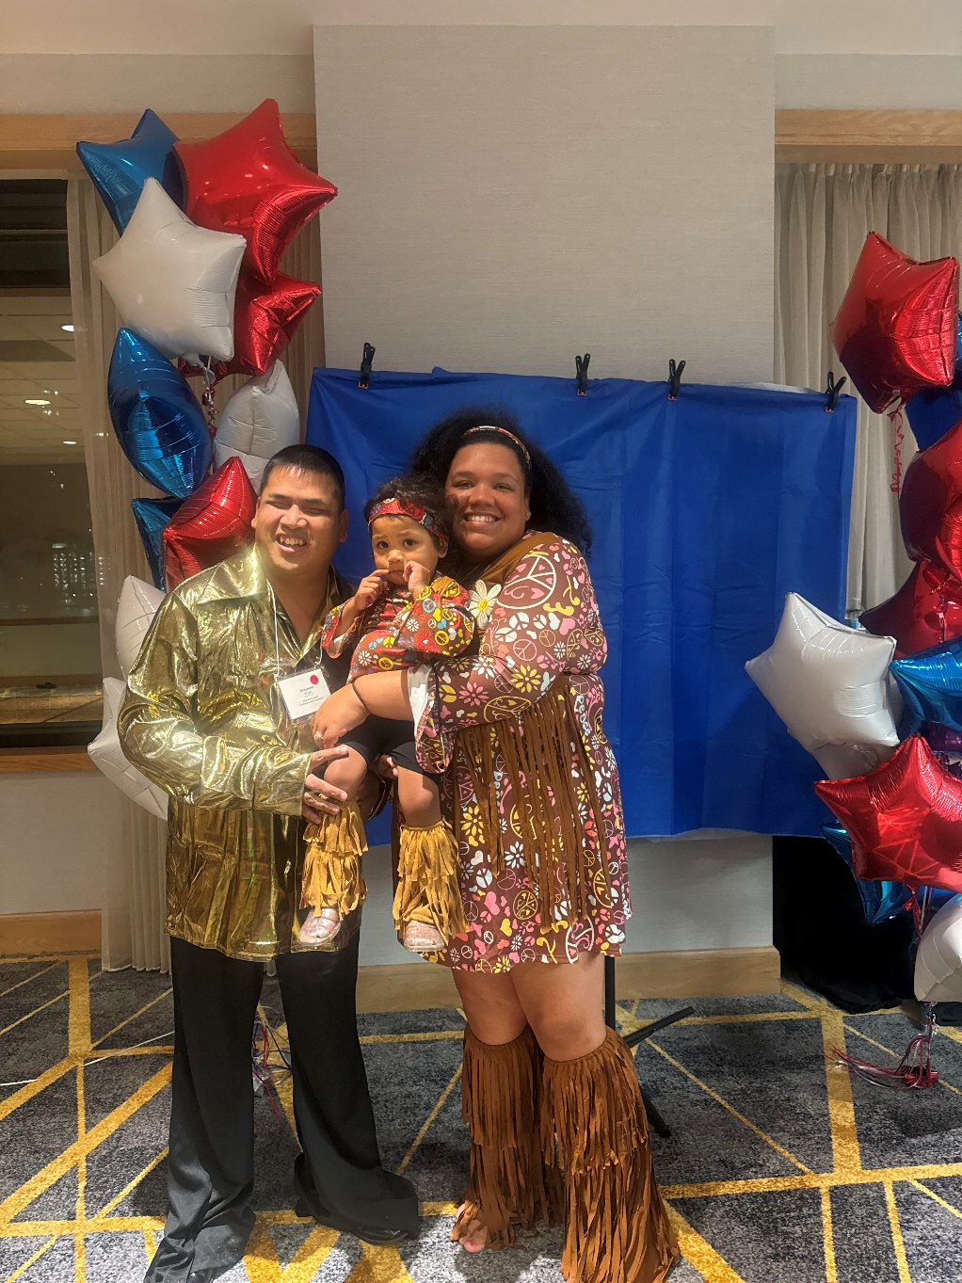CCLVI’s 45th Birthday Dance was a huge success. Benjamin Wright, his wife McKinnley Hayes-Wright, and their daughter Hadassah came out in their bell bottoms and dancin’ shoes. (Photo by Samantha Hubbard)

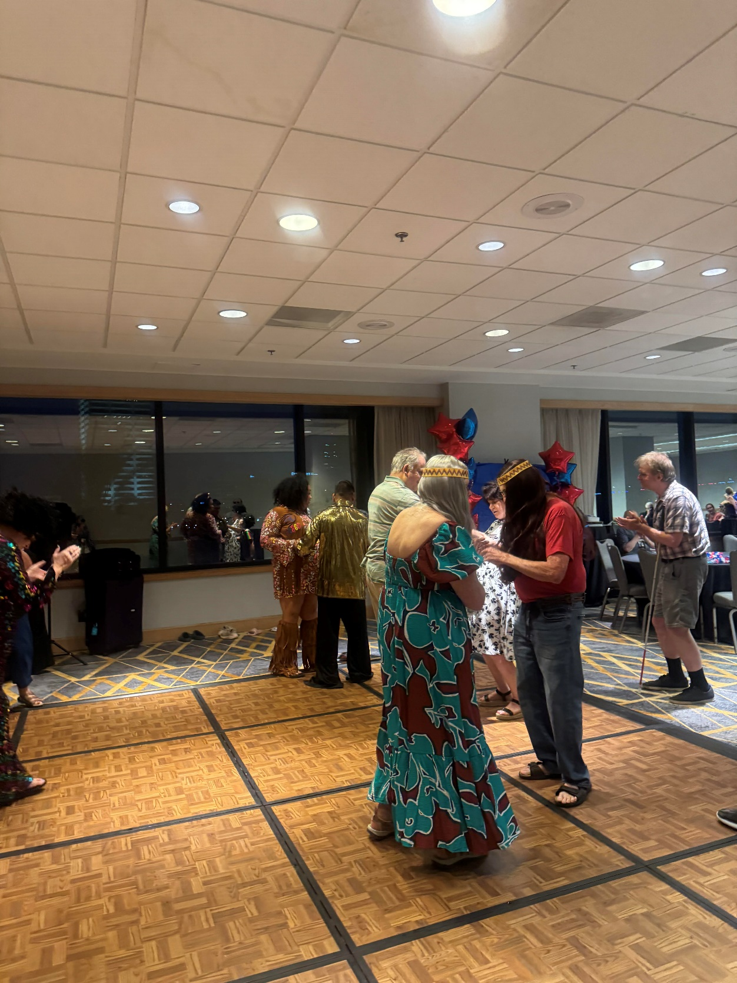Members and non-members alike joined CCLVI to celebrate at the 45 Years of CCLVI Dance. Many took to the dance floor to channel their inner John Travolta and dance the night away. (Photo by Samantha Hubbard)

# **2024 CCLVI Awards**

by Zelda Gebhard, Awards Committee Chair

Our membership organization is totally dependent on individuals sharing their time, skills, and talents. Therefore, it was decided to recognize extraordinary contributions by establishing two awards in 2021.

The Friend of CCLVI was created to acknowledge nonmember individuals, companies or businesses who have been supportive of our members, organization, or programs.

The second award, the Bernice Kandarian Service Award was created to acknowledge a member’s long-term dedication, commitment, and contributions to the Council of Citizens with Low Vision International.

The winner of the 2024 Bernice Kandarian Service Award is Terry Pacheco.

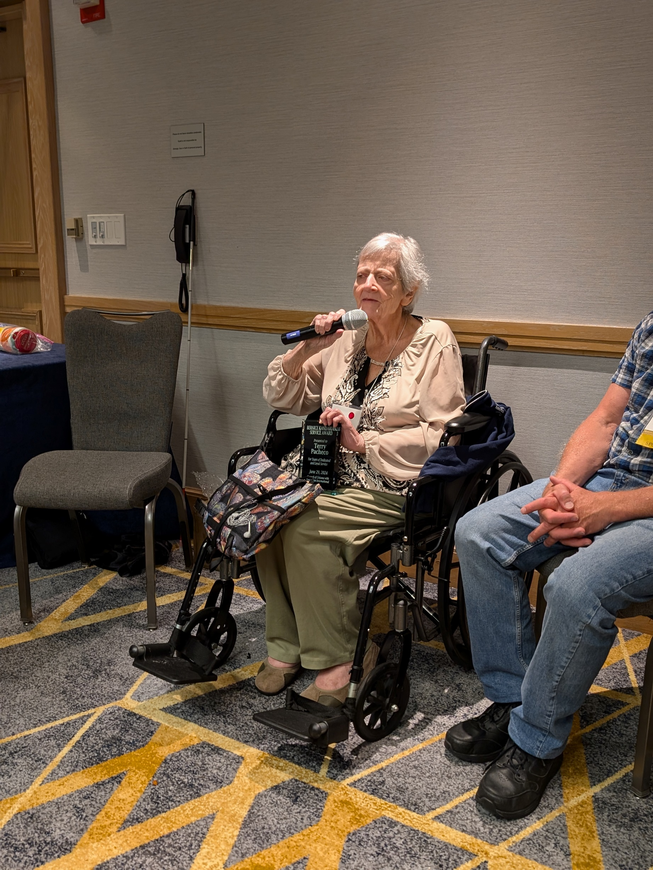**Terry Pacheco**

Terry became a member in 1979. She founded the 1st Boston chapter in 1980. She is the current CCLVI 2nd Vice President and Communications Committee co-chair. She continues to serve us tirelessly as the Coordinator of CCLVI Zoom Programming. She is also active on the following CCLVI Committees: Finance, Fundraising, Resolutions, and Constitution & Bylaws. On top of all she does for CCLVI, we thank Terry for representing the low vision perspective as a director on the ACB Board. Terry, we thank you for your dedicated long-term service. We sincerely appreciate all you do. (Photo by Melanie Sinohui)

# **Meet the 2024 Fred Scheigert Scholarship Winners**

**Aleen Hamlin: Freshman Winner**

Hello, my name is Aleena Hamlin. I was born in Boise, Idaho with the genetic condition called Oculocutaneous Albinism. Although it has created some obstacles in my life with my vision, I have learned to persevere through them.  
  
From the young age of five, I began singing in chorus and playing sports. I played softball, soccer, and, when I started at the South Carolina school for the Blind, I began playing goalball. In goalball, I've won a few awards, one of which being a sportsmanship award.  
  
At the school for the blind, I set a goal to graduate a year. I ended up accomplishing this goal while holding the highest grade point average in both the blind and deaf schools, achieving a 4.4 GPA. I also graduated as valedictorian.  
  
I have been accepted into the University of Alabama in Tuscaloosa, where I will be furthering my education by obtaining my Bachelors in Computer science.

**Nicholas Gural: Freshman Winner**

My name is Nicholas Gural and I am 18 years old from Freehold, New Jersey. When I was 5 months old, I was diagnosed with coloboma, morning glory and nystagmus. As a toddler, I also had retina re-attachment surgery. Despite my diagnosis, I am able to see, but with very low vision. I am not able to see objects that are far away. Since I was born with my eye conditions, I have learned to adapt.

I recently graduated from high school with honors. I was in the Culinary Arts Program all four years of high school. As a freshman during Covid, learning how to use a knife at home while my teacher was on zoom was a bit challenging. I also wrestled for my high school and received my varsity letter this year. In my spare time, I enjoy fishing and hanging out with my friends.

Although there is no cure at this time for my eye conditions, I will not let it slow me down. It might take me a little longer to get things done but it will get accomplished. Technology does help out a lot. I would like to drive one day so hopefully that will happen as technology progresses. I don't live my life with having a disability and I do what other people my age are doing. In the fall, I will be attending Monmouth University in Long Branch, New Jersey and entering my next state in life as an adult.

**Chantale Zuzi: Undergraduate Winner**

Chantale is a senior at Wellesley College and founder of Refugee Can Be, a non-profit to provide education for girls from Uganda's Rwamwanja refugee camp. A survivor of violence in the Democratic Republicof Congo, she found refuge in the US and champions displaced individuals' education and rights. At the camp, Chantale advocated for young refugee women and those facing albinism and vision challenges, liaising with UN workers. Her TED Talk, “It’s Possible to Break Through,” delivers a powerful message of hope. Her personal loss of education fuels her mission to create opportunities for other young girls.

**Ronak Patel: Graduate Winner**

Ronak is a student at the University of Pennsylvania’s Wharton School where he is pursuing an MBA. He grew up in NJ, holds degrees in Finance and Operations Management from the University of Maryland, and spent most of his career in e-commerce and business development across the retail, CPG, and technology industries. Following unexpected vision loss, Ronak took his talent to the American Foundation for the Blind where he serves as the Director of Strategy & Business Development, leading the organization’s corporate partnerships and professional services business. Ronak currently lives in Baltimore, MD with his wife Sonya and dog-child Brooklyn.

# **2024 Genensky-Foley Magnification Award Winners**

by Donna Williams, Genensky-Foley Magnification Award Committee Chair

Congratulations to Angela Randall, Sandi Owens, and Wanda Williford. These ladies were each awarded an iPad courtesy of CCLVI's Genensky Foley magnification award program.

Angela lives in Ohio. Her volunteer work includes teaching craft classes and hosting community calls for ACB. Obtaining an iPad will help her gain more access to small print material such as instructions in crafting kits which will help her expand further in what she can teach. She is also studying python code.

Sandi lives in North Carolina. She is an access technology instructor/trainer and a graduate student. The iPad she receives will help her read instructional information posted at conferences as well as allow her to utilize a larger screen for zooming in on print through work and school apps. This gives her the ability to increase her productivity in work, school, independent living and community service.

Wanda lives in New Jersey. She is president of her local chapter and vice President of the ACB New Jersey affiliate. She is also very involved in her local community. She says her new iPad will help her be more productive as she runs meetings, allowing her to enlarge her agendas and other documents she needs to access.

# **CCLVI Membership Interest and Satisfaction Survey Report**

by Zelda Gebhard, Membership Committee Chair

The membership committee oversaw the development and promotion of the CCLVI Membership Interest and Satisfaction Survey. We received a very good response rate, and we thank all of you who provided information through the survey.

The results will be shared with the CCLVI board and committees and used for future organizational planning and implementation. We will also provide the membership with a general overview of survey results in a future issue of Vision Access.

A random drawing of the survey respondents was held with life member, Lindsey Tilden the winner of the $25

VISA gift card.

The information received through the survey will be helpful to our organization as we evaluate what we are currently doing and make plans for a bright future.

# **Affiliates’ Corner**

**News from NYSCCLV**

by Kathy Casey

Let me introduce myself. My name is Kathy Casey, president of the New York State Council of Citizens with Low Vision. I have been a member of NYSCCLV since its inception. I hope that I’m able to carry out my duties as president.

One of the things I want to do is try to increase our membership. I was given the list of members at large for New York State. I am going to contact them and see if they want to join us.

The Capital District Chapter of the American Council of the Blind of New York is hosting our annual state convention this year. I have invited two eye doctors to speak to us; hopefully they can attend.

Hope all has a healthy and joyful rest of the summer.

**Low Vision Now Upcoming Events**

Saturday, October 5, 2024: 12:45 pm to 2:30pm ET

Speaker: Nutritionist, name to be announced

Topic: Healthy living tips and information

Saturday, November 2, 2024: 12:45 pm to 2:30pm ET

Speaker: Barry Greenbrat, Maxi Aids

Topic: Maxi Aids products for people with low or no vision

# **Have You Heard the Buzz?**

by Cheryl McNeil Fisher

I have been researching smart glasses for over a year. I tried the Seleste glasses, which cost a $100 refundable down payment and a monthly subscription of 50 Canadian dollars. But after six months, I felt they were not for me.

At the end of April, I was back at Ray-Ban and saw the updated AI and the new Skyler frames, which have a feminine look. Two other styles have black frames and choices of clear or colored lenses. They have a 45-day full money-back guarantee. I could try them for 45 days and return them at no cost.

In preparation, I downloaded the Meta View app, so when I received my fully charged glasses, I was ready to go! Every step is user-friendly. The app and glasses will talk you through the process.

During my research, I also tried several handheld and wearable cameras that say they are voice-activated. To have them voice-activated, a sighted person needs to do the setup. Even the Fitbit watch needs a sighted person to set it up. This all means that if there is a problem, I need a sighted person to fix it.

Below, I share a phone number for an exceptional group of accessibility customer service representatives.

So, what do they do?

I ask, “Where’s the milk?” in the refrigerator, and it tells me where it is. At the store, I stand in the snack aisle and snacks and ask, “Where are the Lays chips?” Then I get more specific, asking, “Where are the Baked chips?” In just a minute, I have my hands on the baked potato chips, verifying it with Meta. Meta lets me know the price shown on the shelf. I turn the bag over, and it reads the nutritional facts to me. I can also ask for the serving size, calories, and fat content, and Meta will give me the specific information. Imagine picking up an item and you don’t need to balance it and manipulate a magnifier or other device to figure out the information you want; sometimes it’s simply the size or price.

I was wrapping a gift, and Meta described the paper and helped me pick the ribbon colors I needed. I can read my mail, pick out a greeting card on my own, and the list goes on.

It is the first time in twenty-five years I can read a menu. I ask it what the appetizers are. It will read the headings, and then I ask it to tell me more about the shrimp and the price. So I don’t have to have someone read every item to me or a device read word for word.

Meta is planning to do some Beta testing with Aira, which you only have to pay for if you choose.

I can make video calls using FB Messenger or WhatsApp. You do not need a Facebook account in order to use your glasses.

Live streaming on FB or Instagram and taking 3-minute videos or camera shots are available. I was photographing my dog and could ask Meta if she was looking at the camera. After a few shots of her looking to the side, we successfully captured the perfect photo and background.

Two weeks ago, I was unsure where I was. I was ninety-five percent sure I knew, but something didn’t feel right. I called a friend using Messenger. She was able to see what I was looking at on her phone. She told me to turn my head, then confirmed where I was.

Although the Meta Smart Glasses are made for sighted people, Meta is aware and working toward other features that will enhance the lives of people with visual impairments.

For more information, go to:

<http://www.meta.com/smart-glasses/>

The accessibility phone number is 855-592-2237. Monday through Friday, 8:30 am to 5:30 pm Eastern and Saturday, 9:00 am to 5:30 pm. Several retail stores such as Lens Crafters, Best Buy and Target have the Ray-Ban Meta Smart Glasses and the cost starts at $299 plus Tax.

Before ordering, check your insurance for amount covered for frames, amount covered for lenses (if you need prescription lenses) and in-network providers.

# **The Makapo Aquatics Project Levels the Paddling Field for the Visually Impaired (Part 2)**

by Catharine Griffin

Part 2 of The Makapo Aquatics Project article picks up from the May 2024 issue of Vision Access.

Makapo hosts a few hundred blind and adaptive paddlers a year, including amputees, autistic youth, individuals with traumatic brain injury and many others. Some race competitively. Others gather for Ohana Days, where families can spend the day at the beach and jump into a canoe for the first time. They are working on ways to quantify the therapeutic benefit of being in and around the water, with the goal of securing sustainable funding that could allow for on-site physical and occupational therapists and a full-time leadership staff. A big dream is to convince the International Va'a Federation to create a separate division for blind paddlers - and they've developed a device to make that a reality.

"Right off the bat, we went three feet and flipped in knee-deep water," says Ryan Clary, describing his first paddle almost nine years ago with his dad in an OC2, a two-person outrigger canoe. "That was my first taste of, oh, that's how this is going to be."

Clary was 37, and it wasn't long after his field of vision began to significantly degrade, the onset of retinitis pigmentosa. Makapo came along when his options for doing outdoor activities on his own - like simply going for a jog - disappeared with his eyesight. Paddling gives him precious independence. "I get to go out there and blow out a bunch of energy - no need to worry about what I'm going to run into," he explains. "No tripping on stuff except getting to the canoe."

Now Clary's 46, and on a cloudless October morning in Newport Beach, he's about to race a one-man canoe (OC1) in the annual Off Da Couch race in memory of Sam Couch, a beloved NAC coach and outstanding athlete who had cystic fibrosis. Clary still worries about his balance, but the fact that he's racing an OC1 against more than a hundred sighted athletes is nothing short of incredible. It's possible thanks to Cooperative Outrigger Paddling, or CoOP (rhymes with "scoop"), a remote-control rudder system designed by Mark Baldwin, a Makapo board member and researcher at the University of California, Irvine.

Baldwin began developing the CoOP system in 2018, when De Rama expressed a desire for blind paddlers to be able to train on OC1’s. The challenge aligned with Baldwin's research in assistive technology, and with his knowledge of software engineering and industrial design - and input from the Makapo community - he manufactured a working prototype.

CoOP consists of a receiver with a motor and a battery inside a waterproof housing that attaches to the OC1's rudder cap using a suction cup mount. A remote steersman - in this race, Makapo head coach and board member Rob Octavio - turns a dial on a hand-held transmitter to control the rudder. Octavio follows Clary on a motorboat from about ten yards away (its range is one hundred meters, but the paddler must always be in the line of sight).

There's also a speaker on the OC1 so Octavio can relay information to Clary: "You've got 150 meters to the turn. ... I'm going to be turning you left. ...

You're going to have a wake on your ama [outrigger] in three, two, one - here it is." Octavio says that remote steering requires hyperfocus on ocean and wind conditions, obstacles, positioning - and it's even more challenging because you're also navigating around other boats and making estimates about distances based on varying depth perception. "You can't always be close to the racer, so when he's coming to a turn, if I'm not lined up, I'm wondering, 'Is he at the turn? Am I going to clip the ama?'"

The paddler signals back to the steersman using gestures, like raising the paddle to indicate a problem. Initially, they tried earpieces for two-way communication, but the chatter was distracting. Generally, Baldwin says, when blind people need something, the world will make something for them to hear.

"We don't want to cloud that auditory channel," he explains. "When they're out there they recognize things. They know when we're getting close, because they'll hear the airplanes overhead, or they know we're at Highway 1 because that bridge makes a particular sound."

By using off-the-shelf components and fabricating all the custom parts on low-end, 3D printers, Baldwin kept the cost of the CoOP under $250. He also incorporated feedback from the blind community to improve the design. The latest iteration indicates whether it's properly configured through sound rather than light. The ultimate goal is to minimize the number of people required to get one person out on a canoe. Ideally, CoOP can function with just a paddler and a remote steersman, though launching and landing requires assistance from someone on the beach. Octavio has also been working on a coaching manual to accompany the system that includes commands for verbally steering in case CoOP fails.

Relying on someone else to be your eyes and keep you safe on the water entails what many sighted people might consider an inordinate amount of trust. "In our conditions we don't have a choice. If you don't trust anybody, you can't be out there. The people here are good people - they are looking out for us," says Clary.

"So many 'blindies' have limited opportunities to do anything - some have to plan their ride to the grocery store five days ahead of time. They're intimidated by the world. They're afraid to go out. This is something we have to fight. Just because you can't see, it doesn't mean you can't do it."

Clary says he found Makapo at just the right time. "When you're told at 9 years old, you're going to be blind before you're 40, it's pretty heavy. I did not carry that well. I spent most of my life angry and depressed without even knowing it," he says. "When I got here, it gave me a place to put my energy. Even if you're not conscious of it, paddling calms your soul."

"Even if I'm not balanced in the canoe, I've found more balance within myself," he continues. "My outlook has gone from not worrying about glass half-full or glass half-empty. I get a glass. And when you remember that, then it's always overflowing."

The Makapo team continues to do outreach with CoOP, eager to inspire other communities. It's their hope that in the not-too-distant future, CoOP can be deployed by other canoe clubs with blind paddlers. At the 2022 Queen Liliuokalani Race, where CoOP made its international debut, a woman approached the paddlers at the post-race luau with tears in her eyes.

"She wanted to give us all a hug," Baldwin says. "She said, 'I just found out I'm losing my vision, and I love to paddle. Knowing that there's an opportunity for me to be able to continue doing this just changed my life.' It was one of those moments where we were like, 'OK, we can't do this just in Newport Beach.'"

Source: <https://www.hawaiianairlines.com/hawaii-stories/hana-hou/articles/issue-27-1/guiding-light>

# **Calendar of Events**

Everyone is welcome to attend these events by accessing the Zoom mobile app, visiting the Zoom website at <https://zoom.us> or calling (312) 626-6799, and entering the appropriate meeting ID and passcode.

Subscribe to our CCLVI-Info email list to receive weekly meeting reminders and Zoom details by emailing <CCLVIWebmaster@gmail.com>. In addition, all CCLVI events, except our business meetings, are listed on the ACB Community Call schedule. Those without email can access that information by calling 1-800-424-8666 and following the prompts.

**CCLVI Low Vision Discussion**

Themed chats—First Monday at 8:00 PM ET

Speaker or Themed chat - Fifth Monday at 8:00 PM ET

Meeting ID: 896 8650 7068

Passcode: 225846

**CCLVI Game Night**

Second and fourth Mondays at 8:00 PM ET

Meeting ID: 896 8650 7068

Passcode: 225846

**CCLVI Low Vision Peer Support Group**

Third Monday at 8:00 PM ET

Meeting ID: 896 8650 7068

Passcode: 225846

**CCLVI Board of Directors Meeting**

Second Tuesday at 8:30 PM ET

Webinar Meeting ID: 829 0433 3824

Passcode: 784688

**Let’s Talk Low Vision**

Join our guests for this monthly informative program

First Thursday at 8:00 PM ET

Meeting ID: 874 7608 2312

Passcode: 225845

**CCLVI Table Talk Thursday**

Weekly calls on a variety of topics related to low vision

Thursdays at 8:00 PM ET (except for Book Chat week)

Meeting ID: 828 1584 6310

Passcode: 225848

**CCLVI Monthly Book Chat**

Third Thursday at 8:00 PM ET and the following Friday at 11:00 AM ET

Meeting ID: 898 0359 8659

Passcode: 225843

**CCLVI Affiliate Zoom Calls**

**California Council of Citizens with Low Vision (CCCLV) – A Sunday Chat**

Spend part of your Sunday with members of CCCLV and enjoy “A Sunday Chat”. This is a call for those of us who are blind or with low vision and any family and friends, be they near or far. Topics will range from all things low vision to life in general as a person who is blind or low vision.

First and Third Sunday at 7:00 PM ET

Webinar Meeting ID: 859 2669 0965

Passcode: 282367

**Low Vision Now (formerly Delaware Valley Council of Citzens with Low vision)**

The monthly Zoom meeting Low Vision Now is open to all who have an interest in the issues of low vision.

First Saturday at 12:45 PM ET

(2nd Saturdays in July and September)

Webinar Meeting ID: 440 465 3663

Passcode: 2121

**Kentucky Council of Citizens with Low Vision (KCCLV) - Low Vision Support Calls**

First Wednesday at 8:00 PM ET: Business Meeting

Third Wednesday at 8:00 PM ET: Informative meetings for low vision individuals across the US

Meeting ID: 862 9889 6972

Passcode: 975864

*Topics and speakers are subject to change. Please reference the weekly CCLVI emails and ACB Community Call schedule.

DISCLAIMER: The opinions expressed in the content of this newsletter do not necessarily reflect the opinions of ACB Next Generation as an organization.

|  |  |
| --- | --- |
| **OFFICERS**  **President - Patti Cox 2024-2026**    **1st Vice President - Zelda Gebhard 2023-2025**    **2nd Vice President – Terry Pacheco**  **2024-2026**    **Secretary - Melanie Sinohui 2024-2026**    **Treasurer - Debbie Persons 2023-2025**    **Immediate Past President**  **Leslie Spoone**  **Publications Chair**  **Melanie Sinohui** | **DIRECTORS**  **Cynthia Hawkins 2023-2025**  **Kathy Farina**  **2024-2026**  **Joyce Feinberg  2023-2025**  **Paul Lewis**  **2024-2026**  **Cassie Trosper**  **2023-2025**    **Donna Williams**  **2024-2026**  **Webmaster**  **Joyce Feinberg** |

VISION ACCESS is published four times a year (February 15, May 15, August 15, and November 15) in large print and email.

Vision Access welcomes submissions from people with low vision, from professionals such as ophthalmologists, optometrists, low vision specialists, and everyone with something substantive to contribute to the ongoing discussion of low vision and all of its ramifications. Submission deadlines are January 15, April 15, July 15, and October 15. Send contributions to <CCLVIVisionAccess@gmail.com>