VISION ACCESS
Council of Citizens with Low Vision International
Volume 30 - Number 4 | https://cclvi.org | August 2023
Table of Contents

President’s Message 2
CCLVI Annual Business Meeting Recap 3
A Moment in Dallas 4
A Photographic Glimpse into CCLVI at the 2023 ACB Conference and Convention 6
2023 CCLVI Awards 8
Fundraising News 10
Genensky – Foley Magnification Awards 11
Tech Tips: ACB Convention 2023: CCLVI - Explore the Levels of Low Vision Technology 12
3 Tips from The Blind Kitchen to Help Cooks with Vision Loss 15
Calendar of Events 18

Point and Click
Your Way to CCLVI

President’s Message

I hope everyone who attended the convention - either virtually, in person. or both - enjoyed the programming. All of the CCLVI sessions had great attendance. The Roarin’ 20s party was so roaring that we had to usher everyone out after midnight.

ACB presents a growth award to the affiliate that has the largest number of new members each year. I am proud to say that CCLVI won that award with over 50 new members. I am looking forward to at least 60 new members next year. I want to thank everyone who has become a member or has renewed their membership this past year. Most of all I would like to thank Zelda Gebhard for her hard work as the Membership Chair, making sure everyone who has paid their membership is welcomed into our organization.

In looking forward to the next year, we need YOU to get involved. Become a member of a committee, be a Zoom host and/or facilitator, or even sharing your ideas for programming you would like us to develop.

Finally, I would like to thank the 2023 Board of Directors and our committees for their hard work in keeping up with our website, scholarships, awards, weekly calls, and all the other work that goes into keeping this organization flourishing.

I look forward to working with all of you this year.

Patti Cox
President, CCLVI

CCLVI Annual Business Meeting Recap

CCLVI’s Annual Business Meeting was held virtually on June 24, 2023. A review of the year was completed by the committees and elections were held with the following results.

Board of Directors:
1st Vice President (2-year term): Zelda Gebhard
2nd Vice President (1-year term): Terry Pacheco
Treasurer (2-year term): Debbie Persons
Director 1 (2-year term): Cynthia Hawkins
Director 3 (2-year term): Joyce Feinberg
Director 5 (2-year term): Cassie Trosper

Constitutional Amendments:
1. Purpose - to add omitted text to Article 2.0 of the Constitution to correct a clerical error: Passed
2. Purpose - to add clarification of the president’s duty to provide an agenda before each board meeting as outlined later in the constitution under the secretary’s
Duties: Passed
3. Purpose - to amend the current procedure for receiving board meeting minutes to reflect current best practices: Passed

Bylaw Amendment:
1. Purpose - to remember and honor the efforts of both individuals who promoted and supported the use of magnification devices: Passed

A Moment in Dallas
by Ralph Smitherman

I, Ralph Smitherman, when returning home from the ACB Convention this summer, had a 5-hour layover in Dallas. I was traveling alone and am a person with low vision. I arrived at the Dallas airport around 3pm and while sitting at the gate for about two hours I became hungry.

Someone walked by me with a bag full of food and the aroma was making me hungrier. I wasn’t sure what to do at this point.

News flash; I remembered I have the Be My Eyes app on my smartphone. And, although the airport was very noisy, I thought I would try to make a call for some help. I stood up, made my way to the aisle, and started walking towards what I presumed to be the food area. I made the call and was connected with a friendly assistant.

As I held the phone up so she could read the signs for me, she directed me to turn the phone to the right or left so the signs could be more easily read. I was glad to follow her instructions and I found a place that sold burgers, fries, and drinks.

The food was good, the drink cold and refreshing. I am sure for most people this is not a big issue; however, for a low vision person traveling alone, this gave me the opportunity of an independent moment. I have used the Be My Eyes app many times before; although not in a very noisy setting. When I finished my meal, I returned to the gate to await my flight; and, I was no longer hungry!

A Photographic Glimpse into CCLVI at the 2023 ACB Conference and Convention

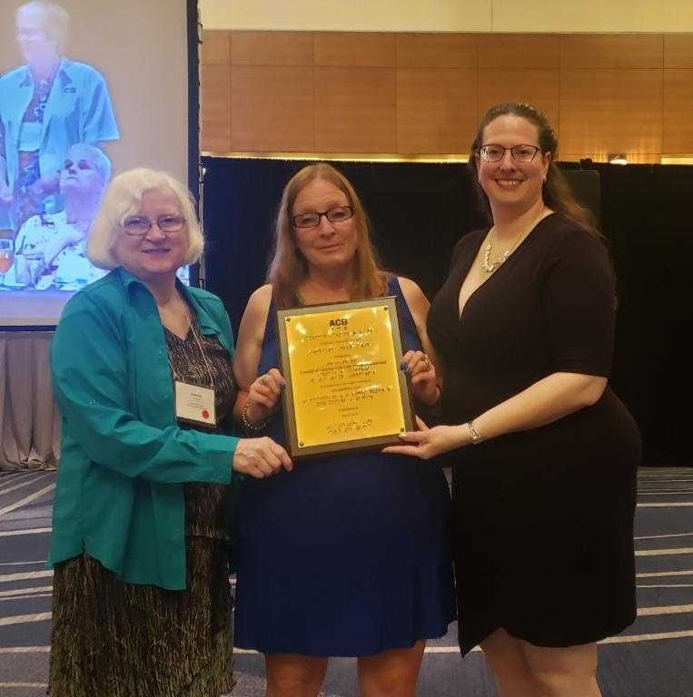
Debbie Persons, Patti Cox, and Melanie Sinohui pose with the ACB Growth Award presented to CCLVI at the ACB Banquet.

(Photo by TerriLynn Higashi)
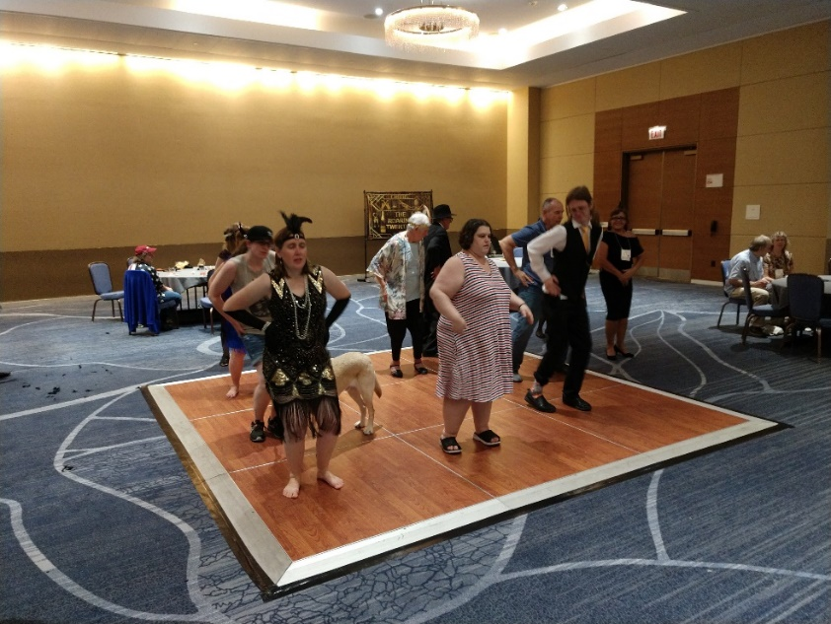
CCLVI’s Roarin’ 20’s Dance was a huge success. Lindsey Tilden, Amber Steet, Eric Malcolm, Andi Thom, and others party the night away on the dance floor.

(Photo by Melanie Sinohui)

A Photographic Glimpse into CCLVI at the 2023 ACB Conference and Convention
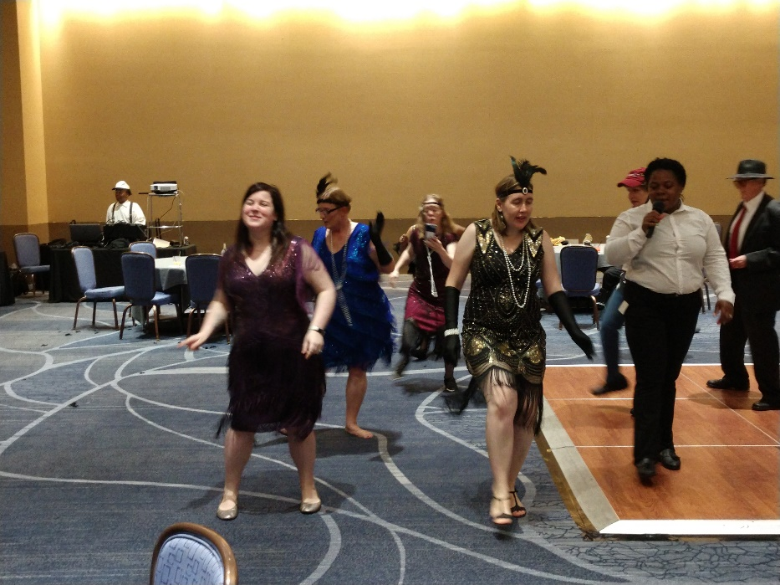
Sara Alkmin, Patti Cox, Samantha Hubbard, and Lindsey Tilden dance alongside one of our DJs giving detailed descriptions of the dance steps.

(Photo by Melanie Sinohui)
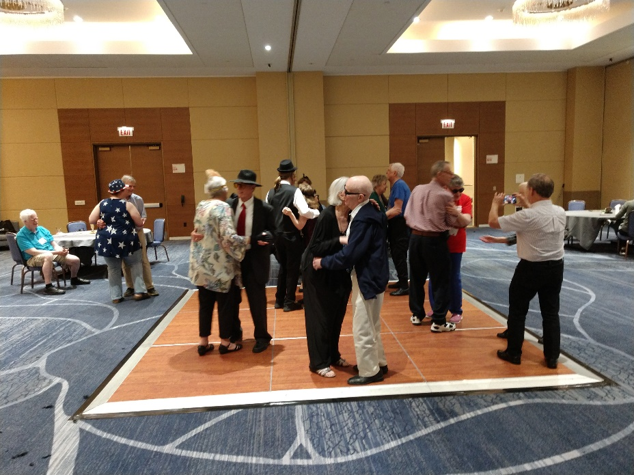
The dance floor is full of couples including Terry and Frank Pacheco, Dave and Win Wilde, Ardis Bazyn and Kevin Berkery, Sam Hubbard and Eric Malcolm among others.
(Photo by Melanie Sinohui)

2023 CCLVI Awards

Having received no nominations for either CCLVI awards from the membership, the Awards Committee nominated and the CCLVI Board of Directors approved to posthumously award the following recipients for 2023.

Bernice Kandarian Service Award
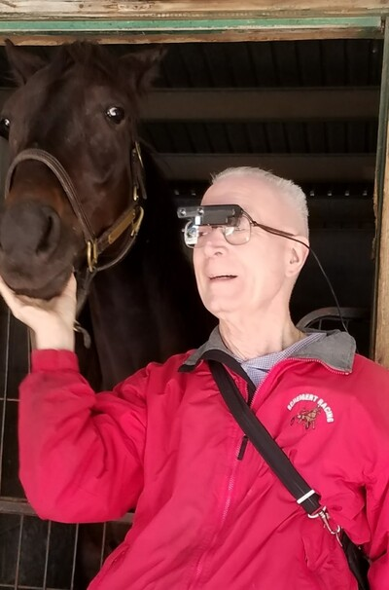
Fred Scheigert was awarded the 2023 Bernice Kandarian Service Award, an award given to acknowledge members who demonstrate exceptional service to our organization. The award was presented in honor of his many years of dedicated service to the organization, for his extremely generous sponsorship of the scholarship program, and for the encouragement and support he provided to many seeking higher education.

Photo Caption: Fred Scheigert wearing his favorite color red jacket with Scheigert Racing written on the upper left chest. Fred is wearing glasses with a magnification device attached. A horse's head resting in his hand. The horse is a beautiful chocolate brown Standardbred horse.

Friend of CCLVI Award
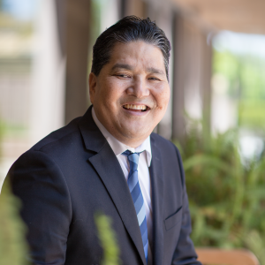
Dr Bill Takeshita was awarded the 2023 Friend of CCLVI Award which acknowledges an individual, organization, or business who has been supportive of our members, programs, or our organization. Dr. Bill was honored in recognition of his extraordinary service and impact as an eye care professional, and for the many years of providing information and hope to countless individuals with vision loss through the “Let’s Talk Low Vision with Dr. Bill” programs.

Photo Caption: Dr. Bill Takeshita sits on a bench, smiling. There is greenery in the foreground of the image on the left side.

Fundraising News
by Kathy Farina

Congratulations to the winners of our Summer Drawing! Patti Cox from Louisville, Kentucky won the first prize of $500. Erica Wolf from St. Louis, Missouri was the lucky winner of both the $100 second prize and the third prize of $90 worth of goodies from Tastefully Simple. We raised approximately $700 for the Samuel Genensky Magnifier Awards. Thank you to everyone who purchased tickets for the drawing.

You can still support CCLVI’s Firecrackers team and the ACB Brenda Dillon Memorial Walk. Half of the money raised comes back to CCLVI, while half goes to ACB. Donations will be accepted until August 31 2023. Go to https://secure.qgiv.com/event/acbwalk2023/team/924696

Thank you to the Fundraising Committee including Renee Zelickson, Paul Lewis, Pat Tusing, James Pulsoni and Patti Cox for their hard work.
If you like fundraising and would like to serve on our committee, contact Kathy Farina, fundraising committee chair, at cclviwebmaster@gmail.com with the following in the subject line attention fundraising. Or call (844) 460-0625. Now is a good time to join committees, as we are recruiting new members. You don’t have to have a lot of experience. We will help you to gain experience. Get involved with CCLVI today!

Genensky – Foley Magnification Awards

Edna Campbell
Edna Campbell Lives in Kentucky and has been visually impaired for 30 years. She volunteers as a greeter at church. When she receives her iPad she will be using it to enlarge and read printed material as well as completing daily tasks.

Vinettea Freeman
Vinettea Freeman lives in Virginia and has been visually impaired since birth. She wants to complete her Master’s degree and only has 2 courses to go. She is looking forward to doing advocacy work as a career. The iPad she receives will help her enlarge print she needs to read such as snail mail and school textbooks.

Marsha Pearce
Marsha Pearce lives in Florida and has been visually
impaired since birth. The iPad she receives will replace a very old one that no longer works. This will allow her to magnify printed material she needs to see in order to complete daily tasks while living independently.

Jeanne Struhar
Jeanne Struhar lives in Florida and has been visually impaired since birth. She currently works as a teacher of the visually impaired as well as volunteers to help with various activities at the church she attends. She plans to use her iPad at home so she can read mail and other small print material related to daily life. It will help her complete tasks independently and more efficiently.

Tech Tips: ACB Convention 2023: CCLVI - Explore the Levels of Low Vision Technology
by Cheryl McNeil Fisher

Based on our member feedback from 2022, CCLVI produced a program at the 2023 convention that focused on the wide variety of technology for those with low vision. Mikey Wiseman and Melanie Sinohui led the conversation with our four panelists and their areas of experience: Cheryl McNeil Fisher (no-low tech), Zelda Gebhard and Charles Cronin (low-moderate tech) on Zoom, and Jessica Dail (high-tech) in person.

From a more philosophical perspective, each panelist was asked, “If you could only choose one thing in your category, what is the one thing you couldn’t live without?” Cheryl cannot live without a pouch of tape that included duct tape, double-sided tape, paper tape, and clear tape in an array of colors, patterns, textures, and sizes. Zelda carries a variety of magnifiers while Charles relies on a full-screen CCTV, and Jessica relies on her iPhone with various magnification and navigation apps.

Some of Cheryl’s favorite things, emphasizing the need for adaptation as her vision changes, are baskets and boxes for organizing and compartmentalizing, and Bungee keychains and a roll of twisty wire to keep things connected and within reach. Cheryl’s overarching message was that we can use many everyday items to keep us independent and organized.

Zelda discussed using low-tech solutions such as magnifiers throughout her home and colored folders for organization. She also uses binoculars for exploring new places and a large monitor with magnification tools. She shared inexpensive tools she uses in the kitchen like something as simple as bending a metal measuring spoon to be able to dip it in a bottle like vanilla, instead of pouring the contents of the bottle into the spoon.

Charles used to rely on reading glasses and a high-powered lamp but found the CCTV to be much more effective. He also uses magnification and screen reader software on his computer.

Jessica uses several apps on her iPhone to make life safer and more manageable. She uses Voiceover on her phone and a screen reader on her PC.

The panelists provided practical insights and personal experiences with low-vision technology. Mikey and Melanie fielded questions from the in-person room and via Zoom. Their professionalism, wit, and humor kept things running smoothly and entertaining. We encourage you to listen to the podcast when it becomes available, where you will find more valuable information and specifics, and delightful personalities.

3 Tips from The Blind Kitchen to Help Cooks with Vision Loss
by Debra Erickson

Tip #1: Start with Hot Soapy Water

Working in a clean and uncluttered environment is a must for blind and visually impaired cooks. One of the best tips I can give you is to run a shallow sink of hot soapy water before you start to work with the food. This is especially important when you are working with foods such as raw eggs, poultry, or fish where harmful bacteria reproduce exponentially at room temperature; ingestion of these bacteria can cause serious illness and even death. Blind or low vision cooks rely on our hands to see for us, and if our hands are covered with raw chicken juice, it will be very difficult to try and turn on our faucet, find the soap, and wash our hands without touching anything. And, if we can reliably remember exactly which surfaces we touched before we were able to wash our hands, we will have to go back and disinfect and clean these surfaces right away. There is a better way! I just run a sink of hot soapy water before I start to cook. This way, if I do have to wash my contaminated or sticky hands, I can find my way to the sink using my uncontaminated forearms to locate the soapy water and plunge my hands into the water without coming into contact with any other surface. The reason I start with a shallow water level is so that I can add hot water to it a little bit at a time so that it is always a nice temperature AND this generally revives more suds. It is very unpleasant to plunge your hands into cold greasy water. I shudder just thinking about it! Another advantage of doing this, is when you have some down time, such as when food is baking in the oven, you can take a few moments to clean as you go, resulting in a cleaner and less cluttered working environment.

Tip #2: How to measure wet ingredients accurately and without waste

Measuring wet ingredients accurately and without waste can be a challenge for people with vision loss. But with The Blind Kitchen Wet measure spoon system - specially marked and shaped spoons, funnel and small pitcher -problem solved! The ladle-shaped spoons help to transfer the liquids efficiently and the small pitcher captures any overflow and the special funnel makes it easy to direct the liquid overflow back into the original container. Efficient and accurate! Go to https://theblindkitchen.com/product/wet-measure-spoons/ to watch a short video to see how it works! These can only be found in The Blind Kitchen. Always free shipping and no retail tax!!
Tip #3: Use tactile dots and stickers for quick identification of seasonings

Salt, pepper, onion powder, and garlic powder are ingredients I use often in my cooking. I keep my salt and freshly ground pepper in identical perfectly shaped cellars that are sturdy, airtight, and almost impossible to tip over. The salt cellar has no marking on it and its top is smooth; salt and smooth both begin with the letter “s” so that is easy to remember. The pepper cellar has a Velcro sticker on its top, which is prickly to the touch: Both pepper and prickly begin with the letter “p” so this makes it easy to remember. The salt and pepper cellars also have airtight gaskets that keep the pepper fresh and dust and critters out. You can learn more about the salt and pepper cellar at https://theblindkitchen.com/product/salt-cellar/ .

The garlic powder is made from only one ingredient, so I put one bump dot on its lid and I know with the touch of my finger what it is. Onion powder also has one ingredient, but it has 2 letter “o”s in the word so its lid has 2 bump dots. Also, easy to remember!

Calendar of Events
Everyone is welcome to attend these events by accessing the Zoom mobile app, visiting the Zoom Web site at https://zoom.us or calling (312) 626-6799, and entering the appropriate meeting ID and passcode.

Subscribe to our CCLVI-Chat email list to receive weekly meeting reminders and Zoom details by emailing our CCLVIWebmaster@gmail.com . In addition, all CCLVI events, except our business meetings, are listed on the ACB Community Call schedule. Those without email can access that information by calling 1-800–424-8666 and following the prompts.

CCLVI Low Vision Discussion
Themed chats—First Monday at 8:00 PM ET
Speaker or Theme Chat - Fifth Monday at 8:00 PM ET
Meeting ID: 896 8650 7068
Passcode: 225846

CCLVI Game Night
Second and fourth Mondays at 8:00 PM ET
Meeting ID: 896 8650 7068
Passcode: 225846

CCLVI Low Vision Peer Support Group
Third Monday at 8:00 PM ET
Meeting ID: 896 8650 7068
Passcode: 225846

CCLVI Board of Directors Meeting
Second Tuesday at 8:30 PM ET
Webinar Meeting ID: 829 0433 3824
Passcode: 784688

Let’s Talk Low Vision
Join our guests for this monthly informative program
Third Tuesday at 8:30 PM ET
Meeting ID: 874 7608 2312
Passcode: 225845

CCLVI Table Talk Thursday
Weekly calls on a variety of topics related to low vision
Thursdays at 8:00 PM ET
Meeting ID: 828 1584 6310
Passcode: 225848

CCLVI Coffee Hour
Fridays at 11:00 AM ET
Meeting ID: 898 0359 8659
Passcode: 225843
California Council of Citizens with Low Vision (CCCLV) – A Sunday Chat
Spend part of your Sunday with members of CCCLV and enjoy “A Sunday Chat”. This is a call for those of us who are blind or with low vision and any family and friends, be they near or far. Topics will range from all things low vision to life in general as a person who is blind or low vision.

First and Third Sundays at 7:00 PM ET
Webinar Meeting ID: 859 2669 0965
Passcode: 282367

Delaware Valley Council of Citizens with Low Vision (DVCCLV)
The monthly Zoom meeting of the Delaware Valley Council of Citizens with Low Vision is open to all who have an interest in the issues of low vision.

First Saturdays at 12:45 PM ET
(2nd Saturdays in July and September)
Webinar Meeting ID: 440 465 3663
Passcode: 2121

Kentucky Council of Citizens with Low Vision (KCCLV) - Low Vision Support Calls
Business meeting, first Wednesday informative meetings for low vision individuals across the US, third Wednesday at 8:00 PM ET
Meeting ID: 862 9889 6972
Passcode: 975864

* Topics and speakers are subject to change. Please reference the weekly CCLVI emails and ACB Community Call schedule.

OFFICERS  President - Patti Cox  2022-2024  1st Vice President - Zelda Gebhard  2023-2025  2nd Vice President – Terry Pacheco  2024-2025  Secretary - Melanie Sinohui  2022-2024  Treasurer - Debbie Persons  2023-2025  Immediate Past President  Sara Alkmin  Publications Chair  Melanie Sinohui | DIRECTORS  Cynthia Hawkins  2023-2025  Tom Frank  2022-2024  Joyce Feinberg  2023-2025  Renee Zelickson  2022-2024  Cassie Trosper  2023-2025  Donna Williams  2022-2024  Webmaster  Joyce Feinberg

VISION ACCESS is published six times a year (February 15, April 15, June 15, August 15, October 15, and December 15) in large print and email.

Vision Access welcomes submissions from people with low vision, from professionals such as ophthalmologists, optometrists, low vision specialists, and everyone with something substantive to contribute to the ongoing discussion of low vision and all of its ramifications. Submission deadlines are January 15, March 15, May 15, July 15, September 15 and November 15. Send contributions to CCLVIVisionAccess@gmail.com

