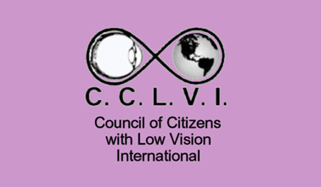
Council of Citizens with Low Vision International.
www.cclvi.info

Listening to Podcasts

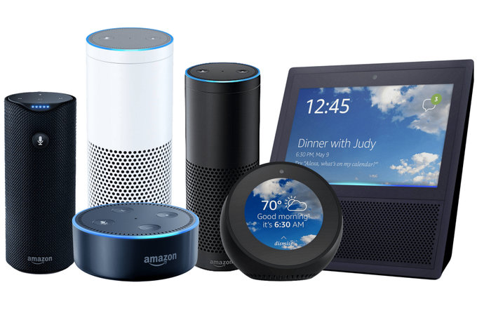
There are many easy options for listening to CCLVI’s Let’s Talk Low Vision and other CCLVI podcasts. Listen on your smartphone, tablet, computer, Alexa or Echo, Google Home, or Victor Reader Stream. Read on for sample instructions; we use Let’s Talk Low Vision as the example.

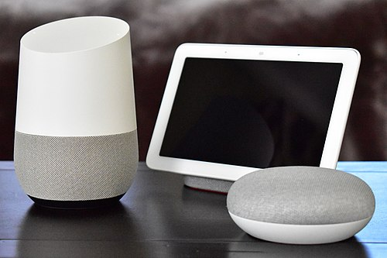
Alexa/Echo – “Alexa, play the podcast Let’s Talk Low Vision”

Google Home - “OK, Google, play the podcast called Let’s Talk Low Vision.”

Siri
Siri devices – ‘Hey Siri, play Let’s Talk Low Vision”

Victor Reader Srream
Victor Reader Stream- click this link for instructions.

Listen with Your Favorite Podcast Application
Apple, Google, Amazon Music, Stitcher, Overcast… whichever podcast site or app you use, you can listen or subscribe to our podcast for free.
In you podcast listening application, search for Let’s Talk Low Vision, and you will see an option to listen or “subscribe.” Just click the relevant button to listen to the episode that is there on your screen.
If for some reason you have difficulty finding our podcast with the search function, you may find the Let’s Talk Low Vision podcast directly by adding our feed https://pinecast.com/feed/let-s-talk-low-vision-cclvi

Subscribe
You may also have every episode delivered directly to your device by clicking Subscribe!
When you click “Subscribe” in your podcast program, the system will do the rest. From then on it will automatically retrieve the newest titles once they are available. When you are ready to listen, click a new episode and it will play and download simultaneously.
Questions?
If you have questions about Let's Talk Low Vision or you have suggestions or topics for consideration, please send an email to: CCLVIWebmaster@gmail.com

